Lab 6: Update Sequence Number (USN) Journaling
What You Need for this lab
  - Install Virtualbox : https://www.virtualbox.org/wiki/Downloads
  - Install Kali 2021.4. : https://old.kali.org/kali-images/kali-2021.4/
    - Notes: Suggest You configure the disk size of Kali VM 80G because the size of each leakage cases image is 30G+
- https://www.dropbox.com/sh/3lyzpi7vyod0pfs/AADh2b3TnmMqWZHB1Uzv9_ma?dl=0
- https://ubaltmy.sharepoint.com/:f:/g/personal/id31ga53_ubalt_edu/EoJThlUPE85Hm7592HB5sjIBGo4Ht9drLxt9XnwDdnf3PA?e=4Okj4m
- https://github.com/jschicht/ExtractUsnJrnl
  - Image .dd from Lab 5
Scenario 1
- Install UsnJrnl2Csv tool
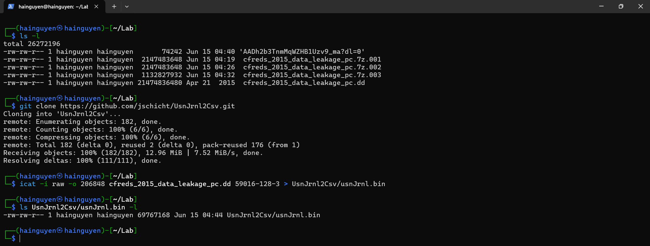
- Run UsnJrnl2.exe to covert UsnJrnl.bin to .csv
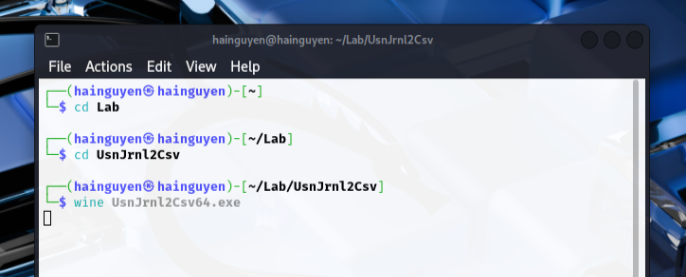

- Set configuration: Browser to usnJrnl.bin
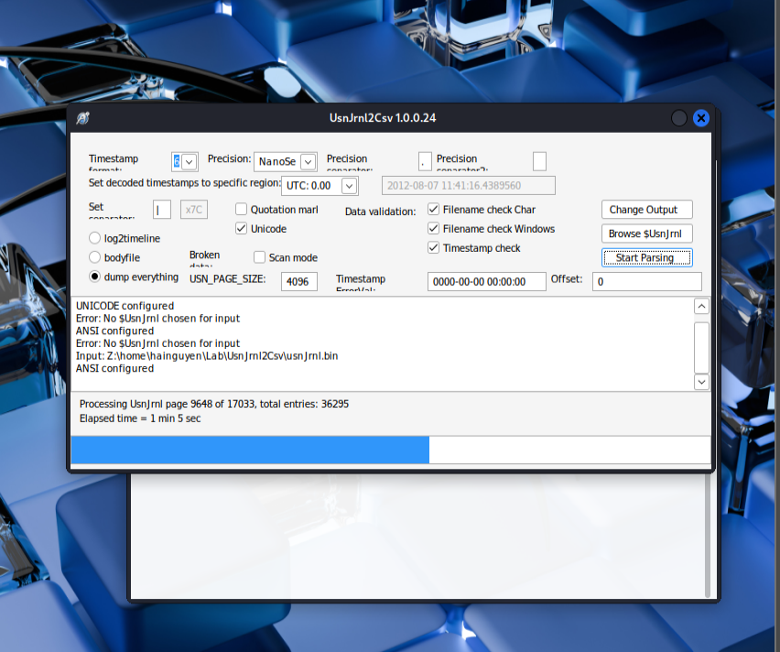

- Show the extracted USN journal file
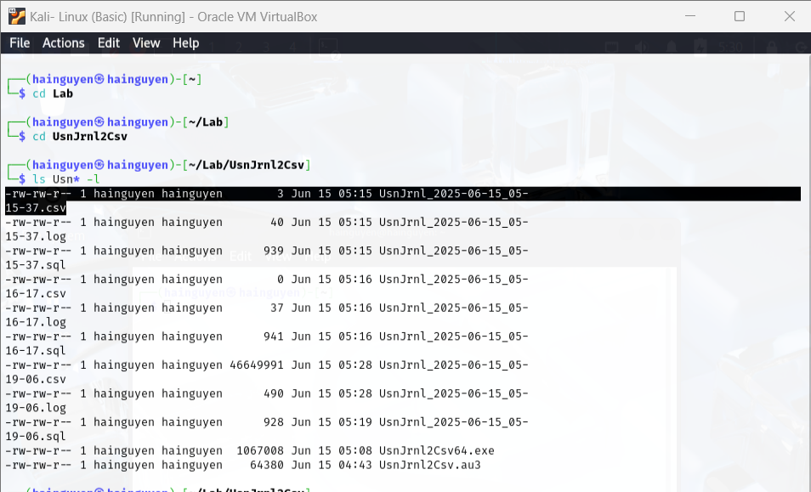
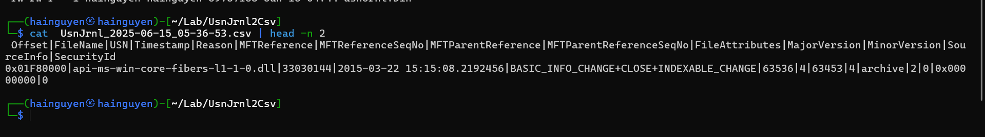
- Only show “RENAME_OLD” information of any .jpg files
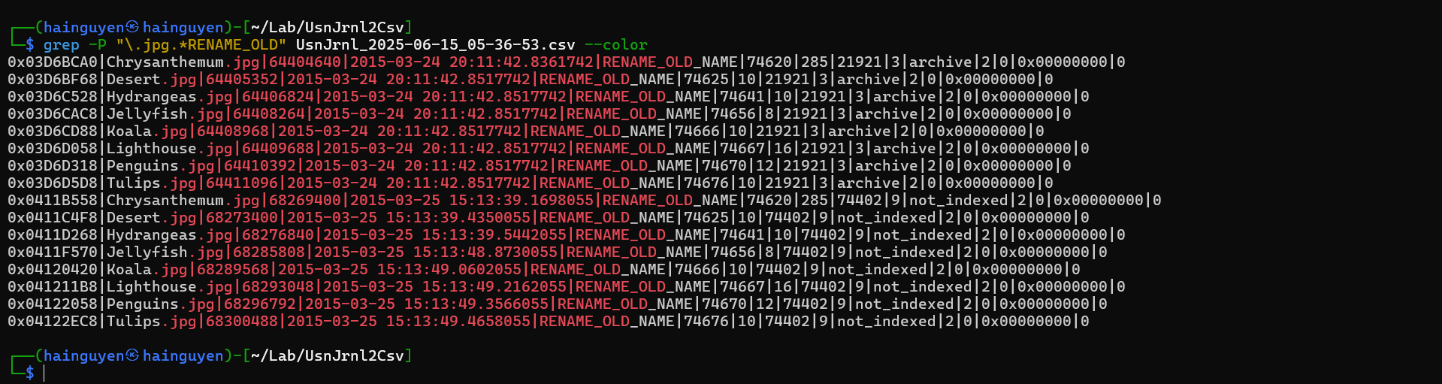

- Only show “RENAME_OLD” information of any .jpg files. Only show three columns, FileName, Timestamp, Reason
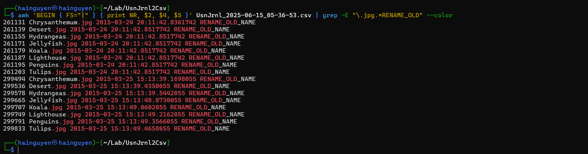
- Show what has happened around a specific time with the same MFT reference #
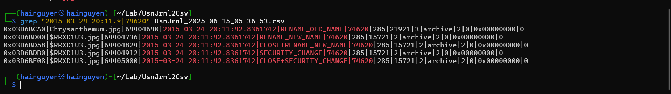
Scenario 2
- Install usncarve tool (note we have changed the path)
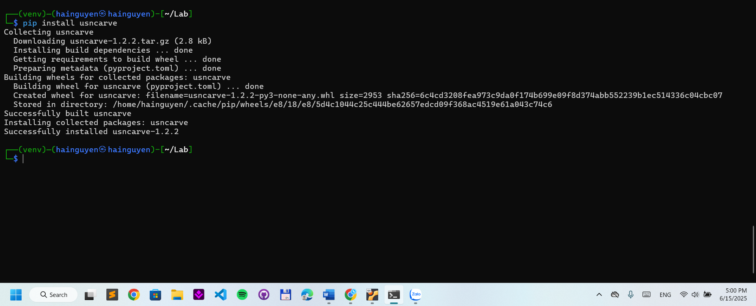
- Verify installation
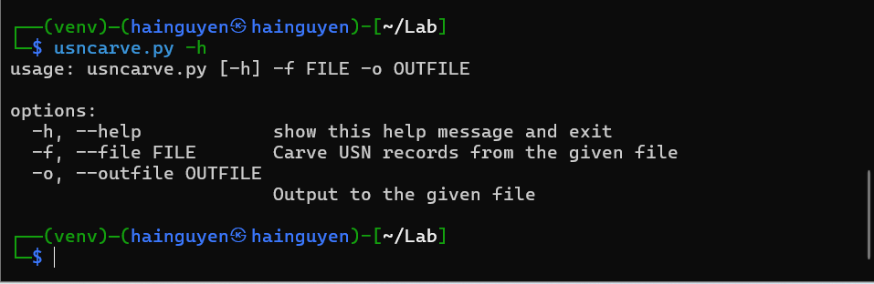
- Install usnparser tool
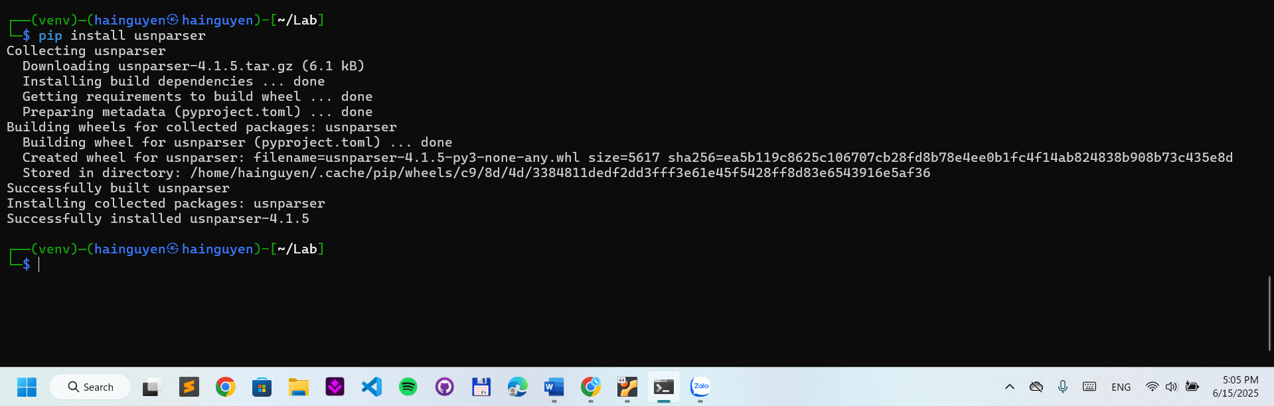
- Verify installation
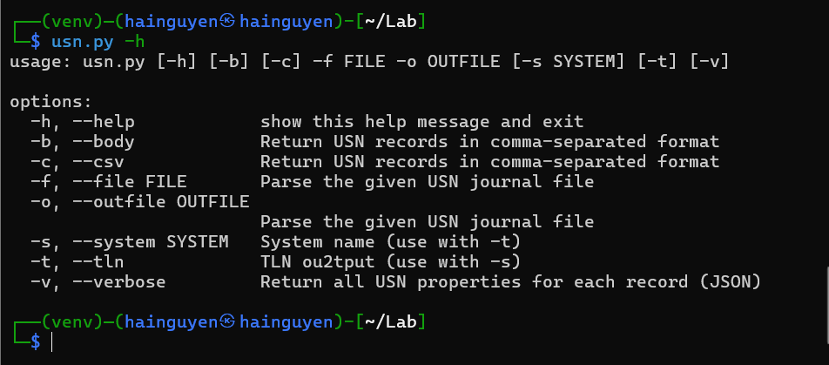
- usncarve.py -f input file -o output file
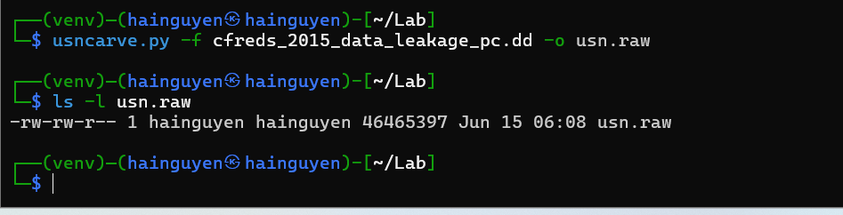

- usn.py -f input file -o output file
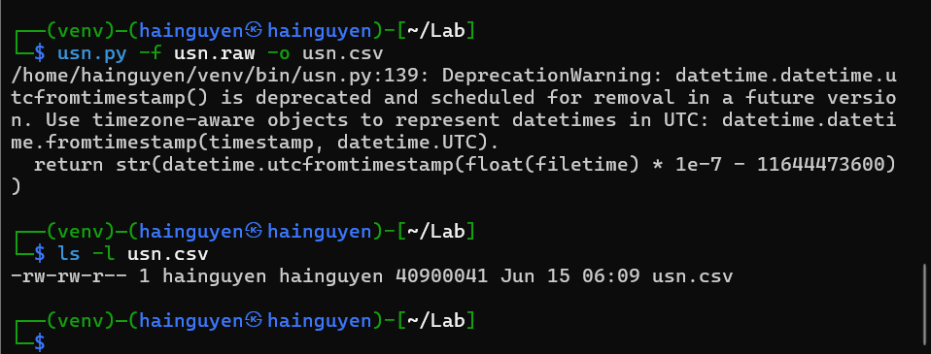
- View renamed files
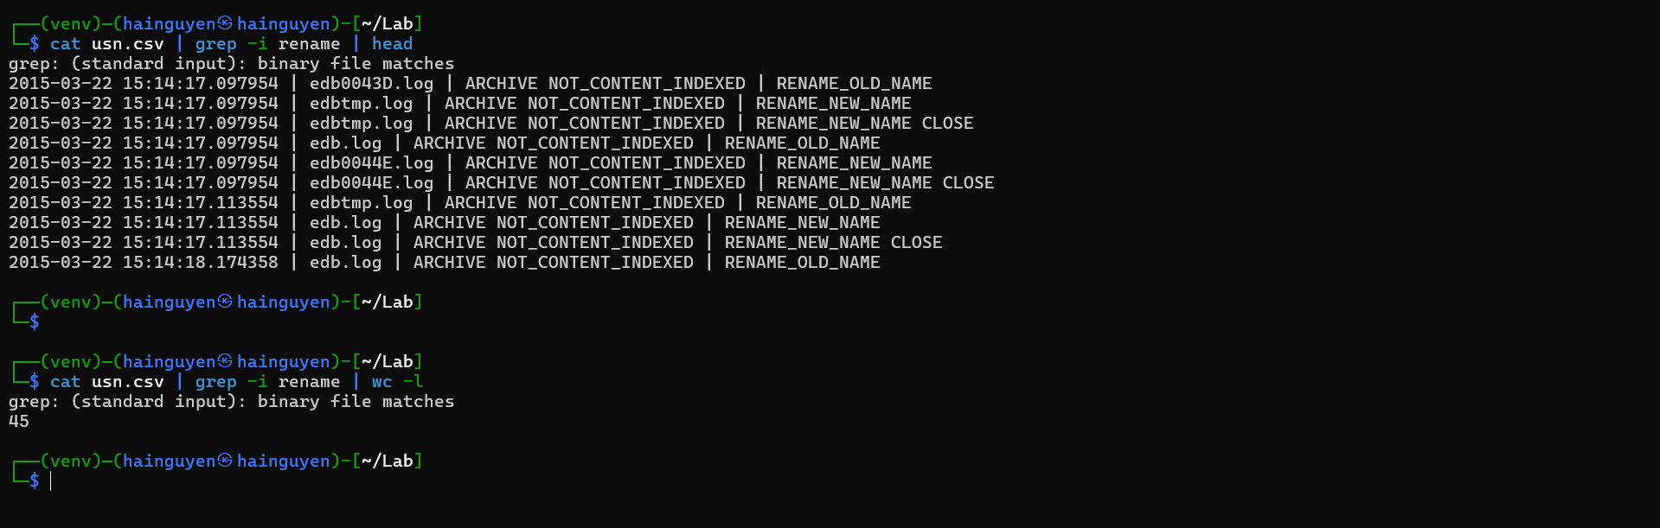

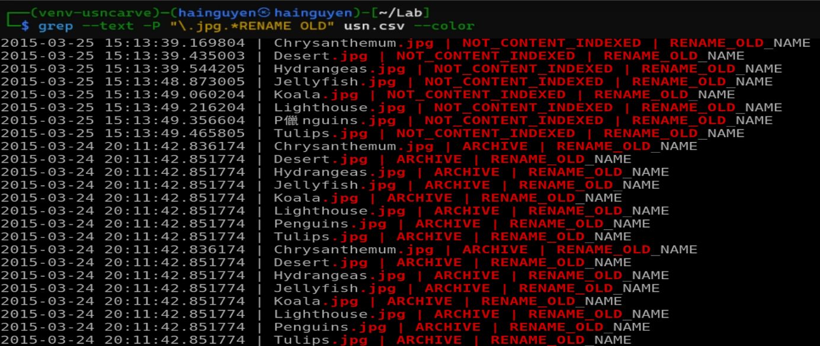
YOU MUST SUBMIT A FULL-SCREEN IMAGE FOR FULL CREDIT!
Save the document with the filename "YOUR NAME Lab 6.pdf", replacing "YOUR NAME" with your real name.
Email the image to the instructor as an attachment to an e-mail message. Send it to: xxx@fe.edu.vn with a subject line of "Lab 6 From YOUR NAME", replacing "YOUR NAME" with your real name.

